**Tour de France Outdoor Sports Cycling Wind Rain Coat Long Sleeve Jacket Jersey**

**Introduce:**  
Thin imitation splashing fabrics. Roll up small size, easy to carry, can be directly put jersey pocket. Evening or early morning ride down the mountain can be worn both windproof and can not catch a cold  
  
Suitable for wearing in spring cycling season, to shelter; clothing with reflective strips and back pockets, clothes have pockets on both sides, practical and beautiful, but the back of the grid with breathable layers, folded up when not wearing only palm-sized can be placed in pocket. Collar design humane, zipper does not touch the skin, to avoid friction causes discomfort, clothes back reflective strips, night riding safer and reflective strips under the pocket for easy riding belongings but also can split up after loading into the bag and carry it easy to go out  
  
**Features:**  
Super light and waterproof made make your enjoy cycling in the rain  
Full open zipper used to lock the zipper puller  
Unqiue design make your cycling more attractive  
Rear pockets for keeping small items .  
Reflective Logo make your cycling more safety  
Sublimation printing technology used , bright color and never fade  
Mesh material design on the back  
1 pocket on the back and 2 pockets on the side with zipper  
  
**Specification:**  
100% Brand New  
Color: Black, Green, Orange, White  
Material: 100% Polyester  
Available Size: S, M, L, XL, 2XL, 3XL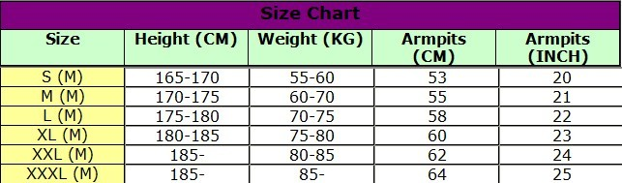

**Package Contents:**  
100% Brand New  
1x  Cycling Coat  
  
**Wash:**  
Wash with cool water: 40°C  
Do not brush, Do not bleach  
Do not dry clean  
Do not tumble dry