ZTW Spider Series 30A OPTO Brushless Speed Control ECS for Multicopter Qudcopter Airplane Part

ZTW Spider Series 30A OPTO Brushless Speed Control ESC 2-6S Lipo for DJI Flame Wheel F450 F550

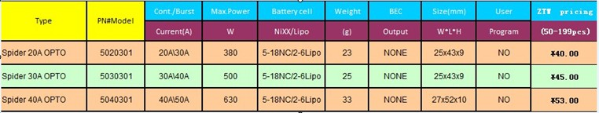

Features:

Continuous Output: 30A

Burst Output: 40A

Max. Power: 500W

Battery: 5-18NC/2-6Lip

Length: 43mm

Width: 25mm

Height: 10mm

Weight: 26g

Supports high RPM motors

Extremely low internal resistance

Super smooth and accurate throttle linearity

Safety thermal over-load protection

Auto throttle shut down in signal loss situation

Power arming protection (prevents the motor from accidentally running when switched ON)

Use new generation of the MOSFETs ensuring low heating and more reliability operation

Package Include:

1 x ZTW Spider 30A ESC